- Install git.
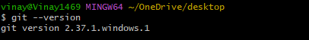
- Create a repo in github with README.md and .ignore file.
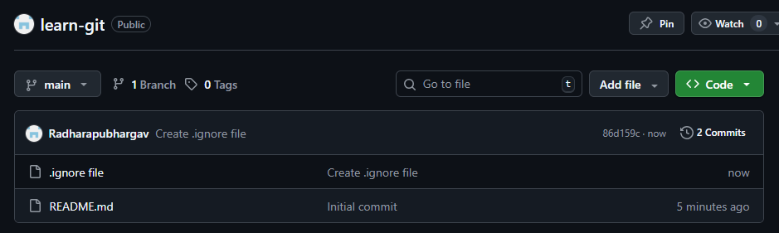
- Clone the created repo to local.
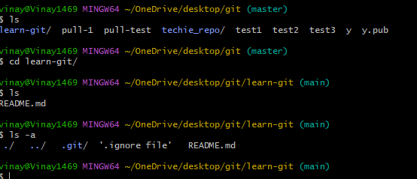
- Create two files in local repo.
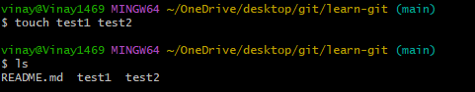

- Commit two files and push to central Repository.
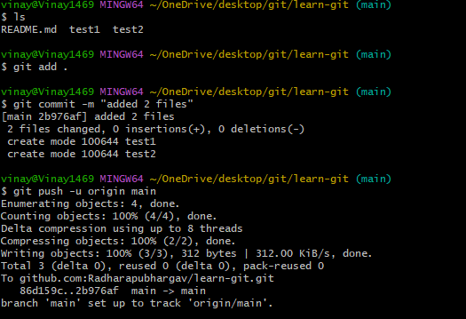

- Create a branch in local and create a sample file and push to central.
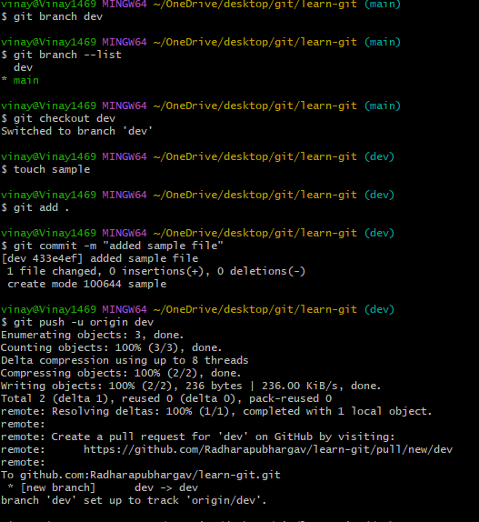
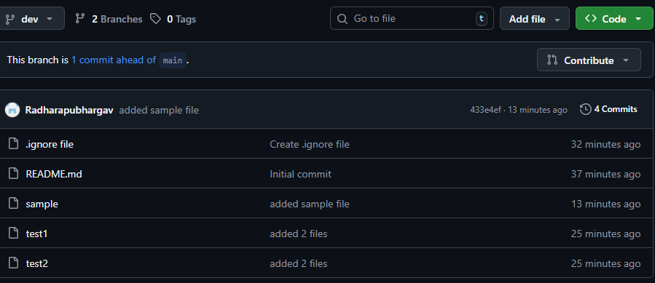

- create a branch in github and clone that to local.
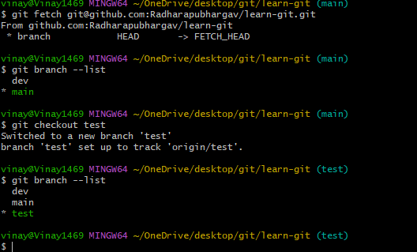
- Merge the created branch with master in git local.
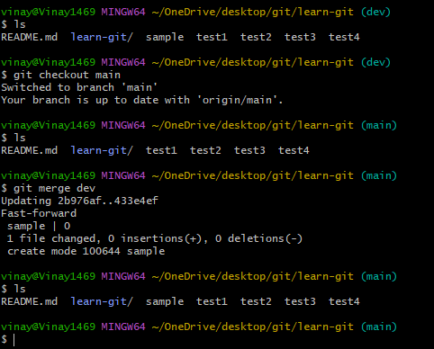

- Merge the created branch with master in github by sending a pull request.
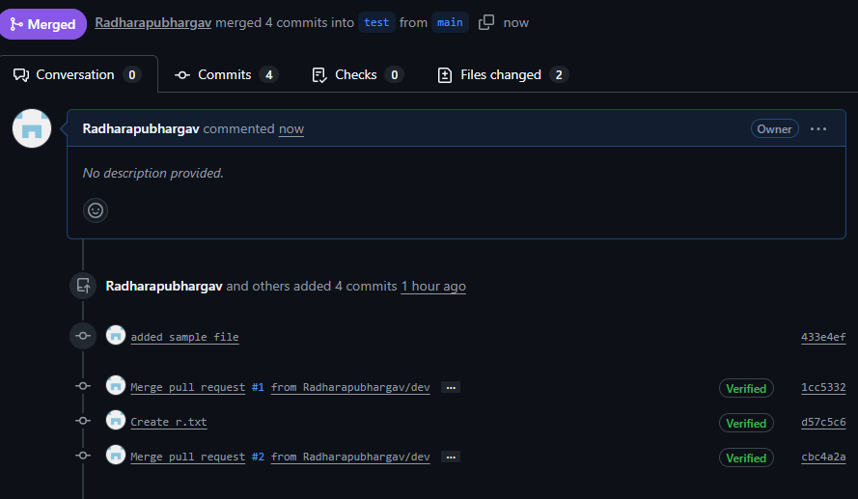
- Create a file in local and send that to branch in github.
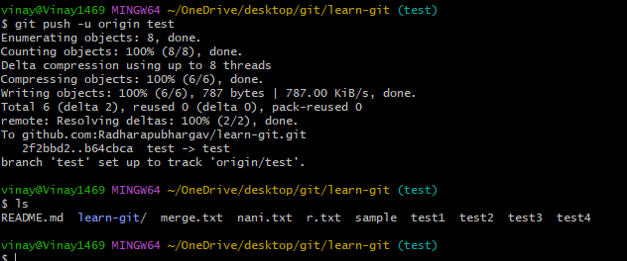

- Clone only a branch from github to local
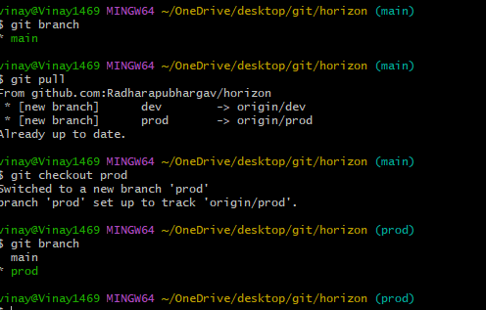
- Create a file with all passwords and make that untrackable with git.
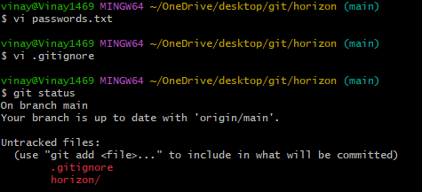
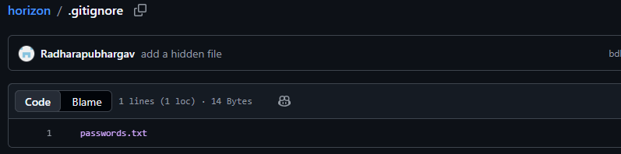
- Make a commit and make that commit reset without savings changes.
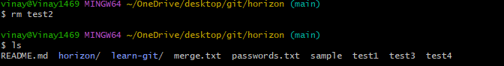
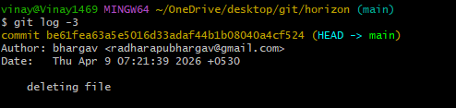
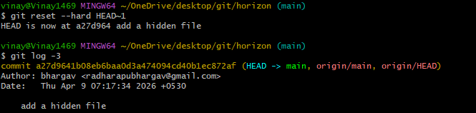
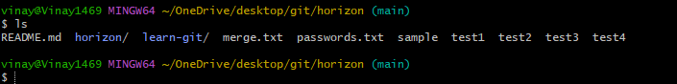
- Revert a commited commit to the older version.
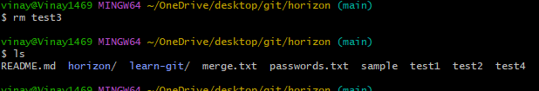
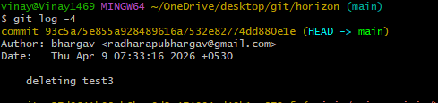
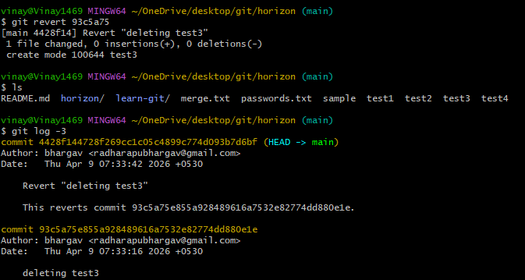
- Push a file to stash without savings the changes and work on another file.
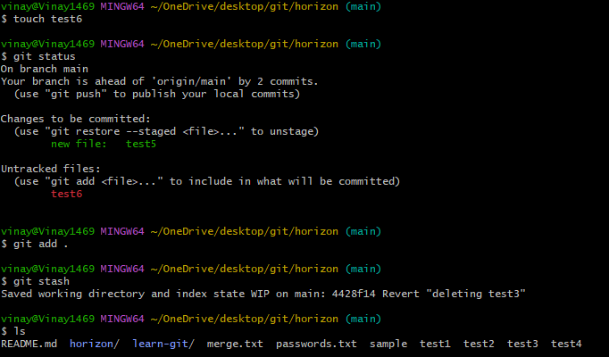

- Undo the stash file and start working on that again.
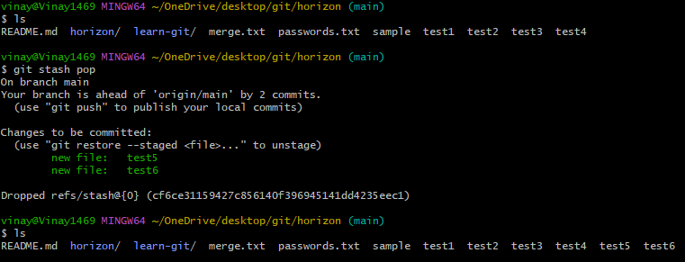
- Generate a ssh-keygen and configure into github.
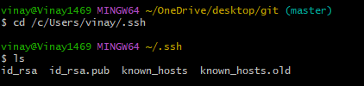
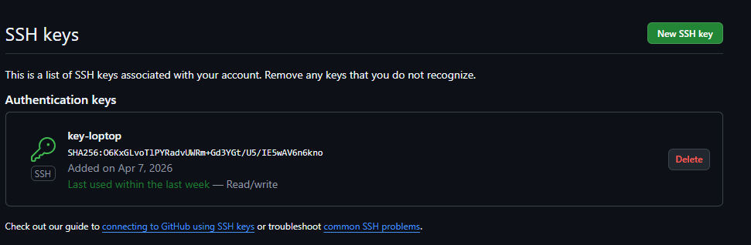
- Configure webhooks to github.
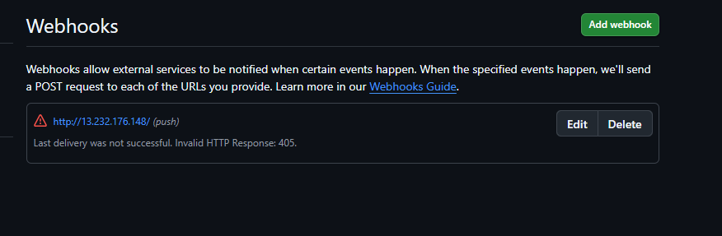

- Basic understanding of .git file.
The .git folder is the heart of Git inside your project
Where is it?
When you run:
git init
Git creates a hidden folder:
.git/
You can see it using:
ls -a
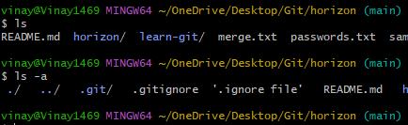
- Check all the logs of git.
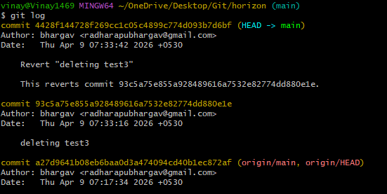

- Rename the commit message.
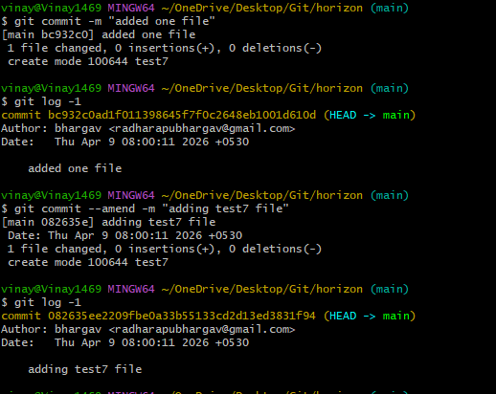
- Merge multiple commits into single commit.
